2-1 Assignment: CRUD in MongoDB

Cristiano Miranda
Southern New Hampshire University
CS-340: Client/Server Development
Professor Badam
15 March 2026

2-1 Assignment: CRUD in MongoDB
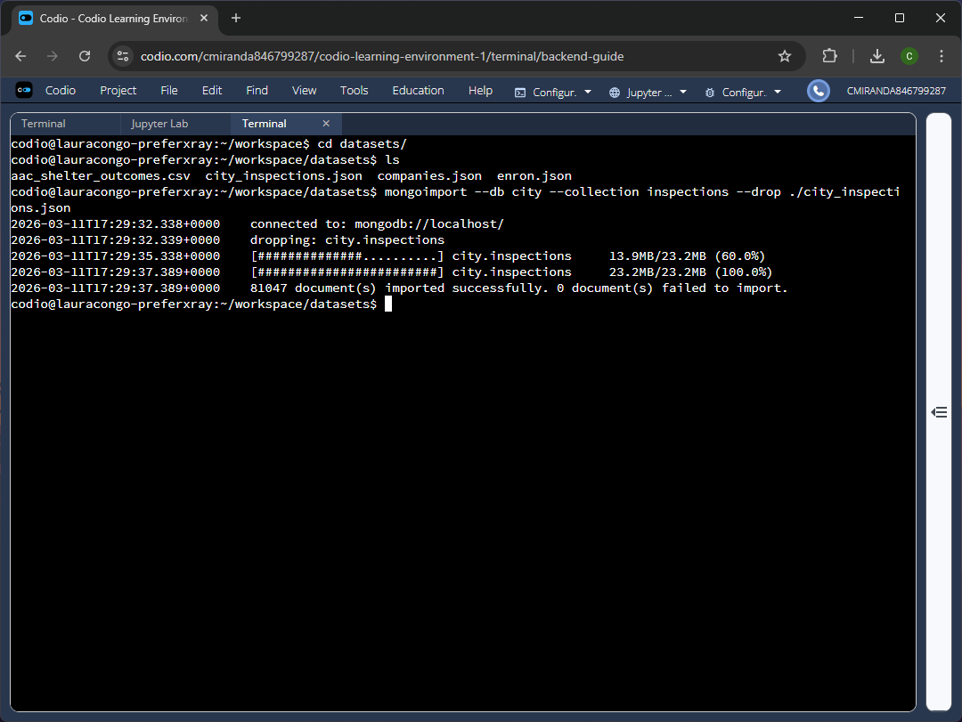
Figure 1 - Accessing the city_inspection.json file and importing it into the ‘city’ database as the ‘inspections’ collection.
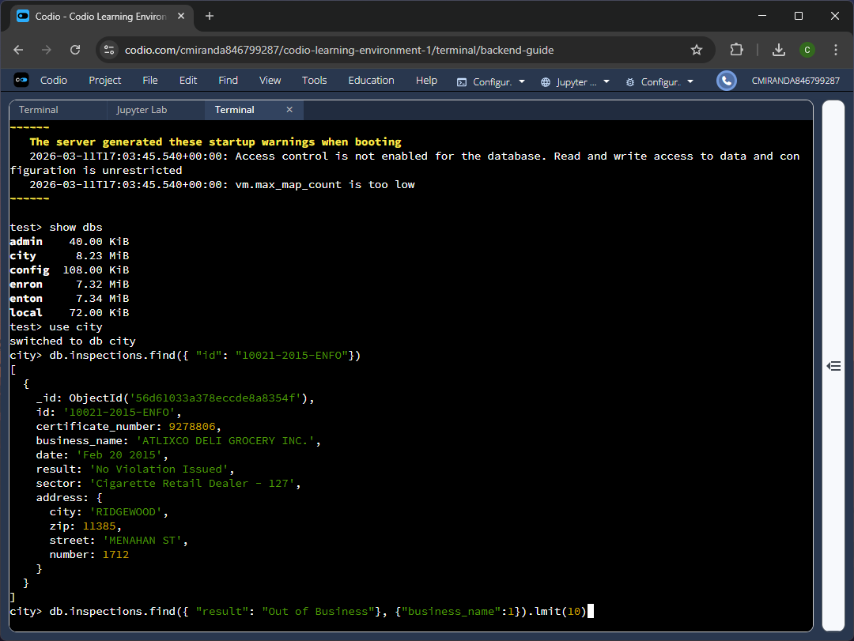
Figure 2-1 - Validating the import by executing the find command with a filter to find a single entry.
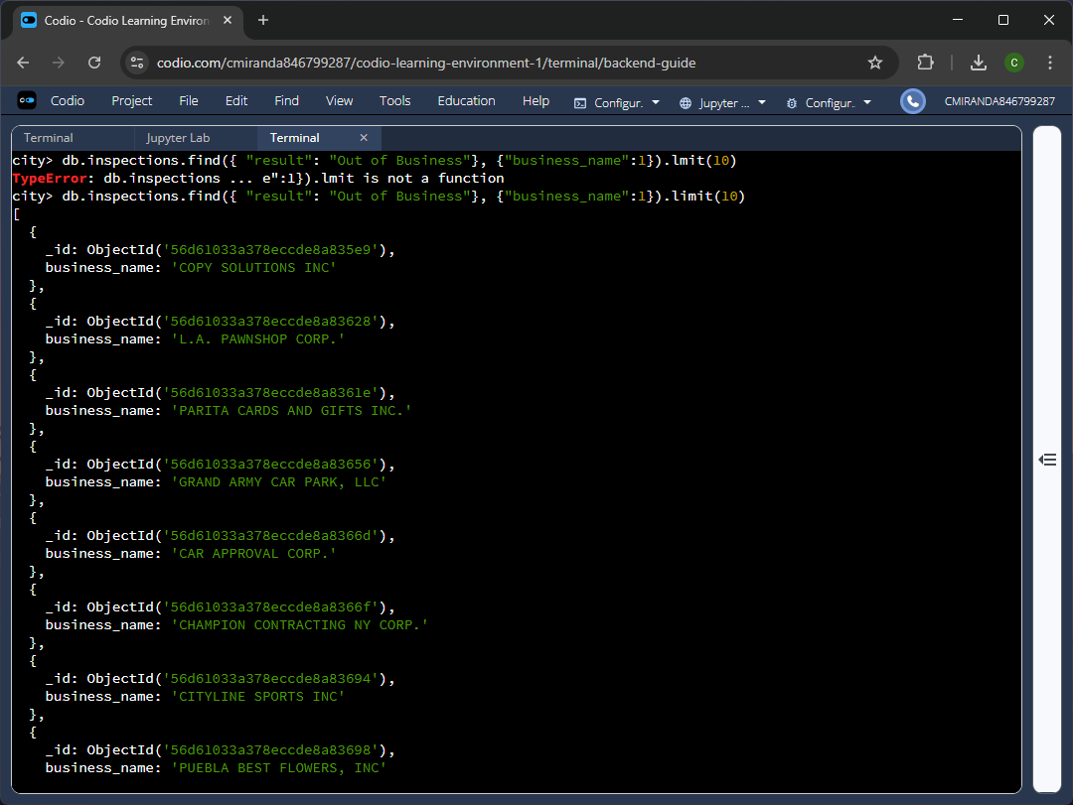
Figure 2-2 - Validating the import by executing the find command to find multiple entries.
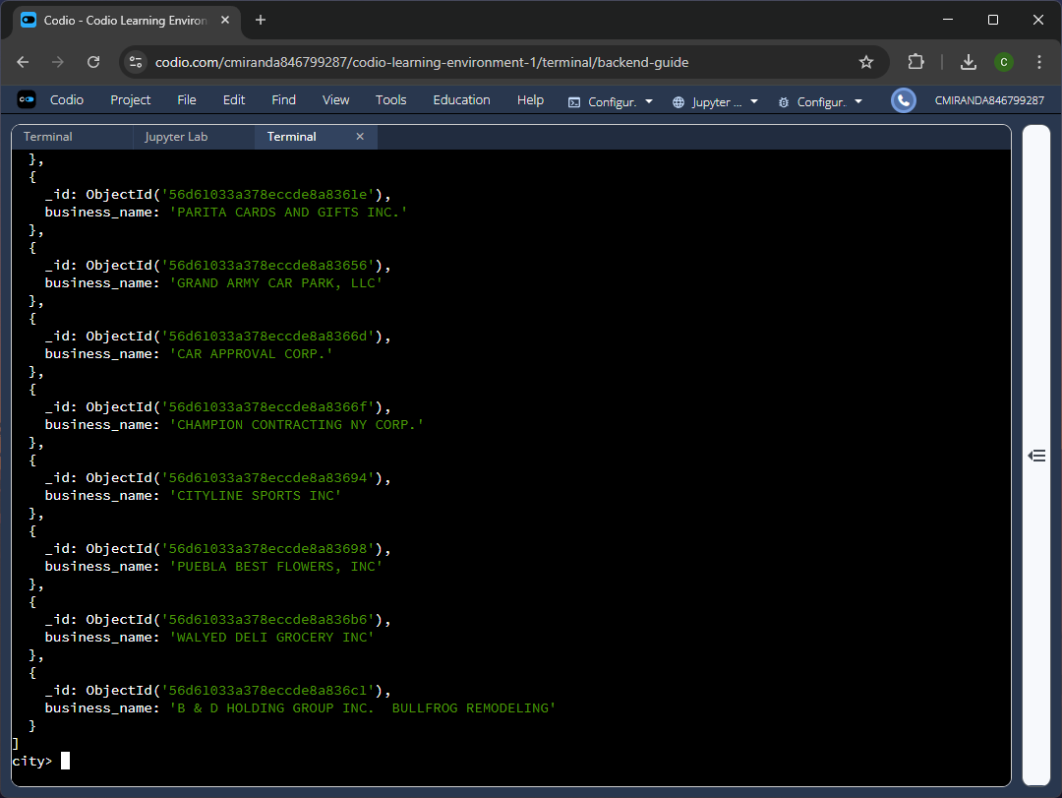
Figure 2-3 –Remaining entries.
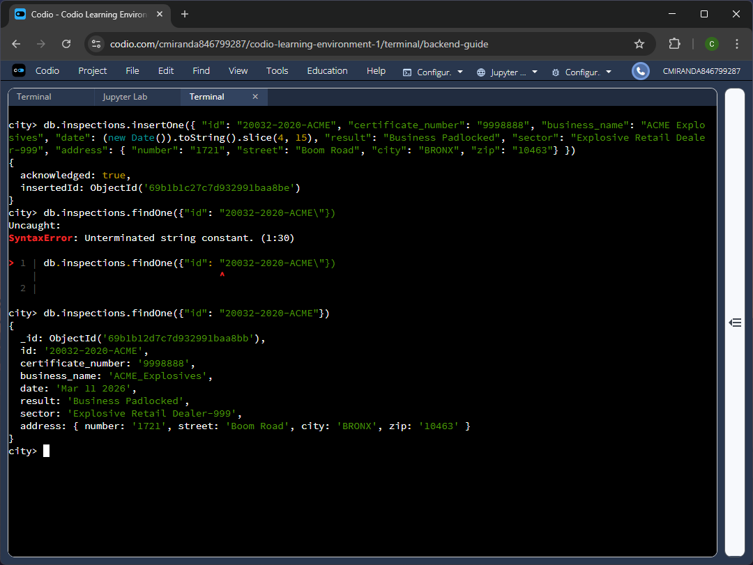
Figure 3 – Inserting a document into the ‘city’ database and in the ‘inspections’ collections and then validating the entry using the find command.
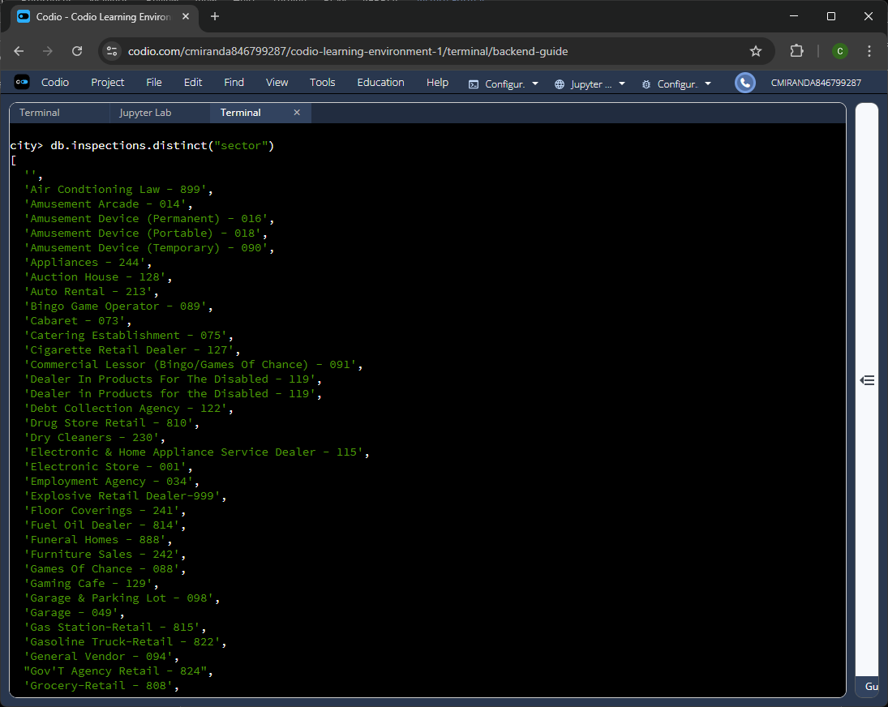
Figure 4A-1 – Generating a list of unique inspection “sector” from all entries within the collection.
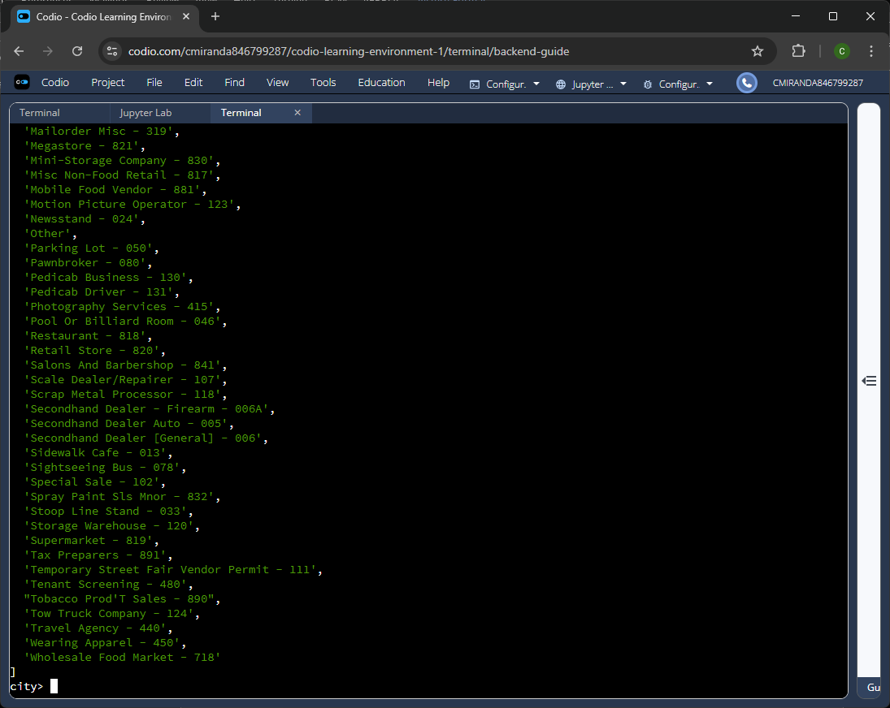
Figure 4A-2 - Remaining unique inspection “sector” entries within the collection.
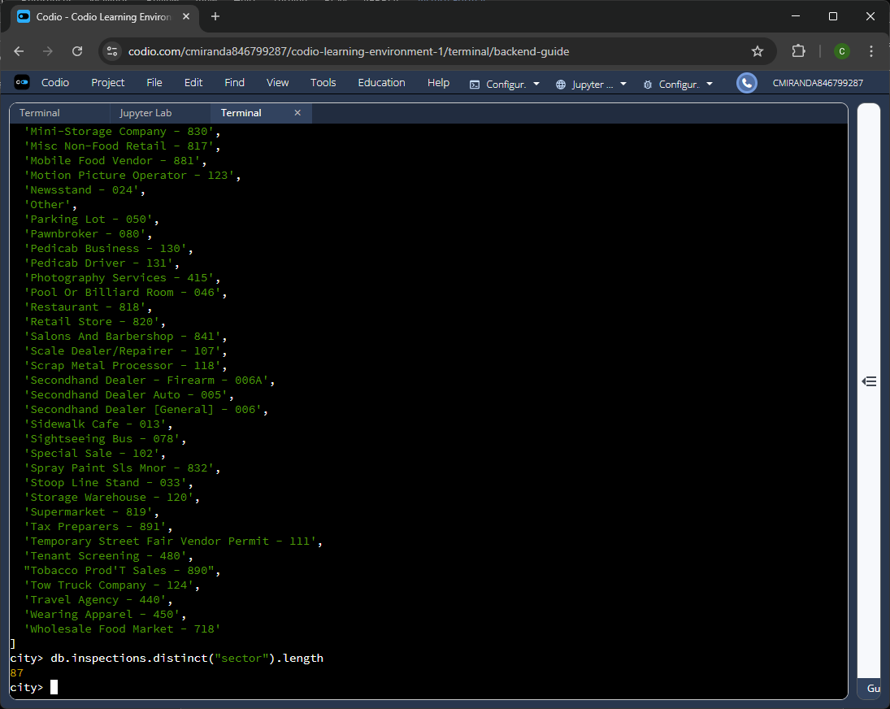
Figure 4A-3 – Total count of the unique inspection “sector” entries within the collection.
Using the distinct command and specifying “sector” field allows for the generating of a list of all unique “sector” values and finding the length property of this list allows for determining how many unique sector values are within the collection, a total of 87 unique sector values.
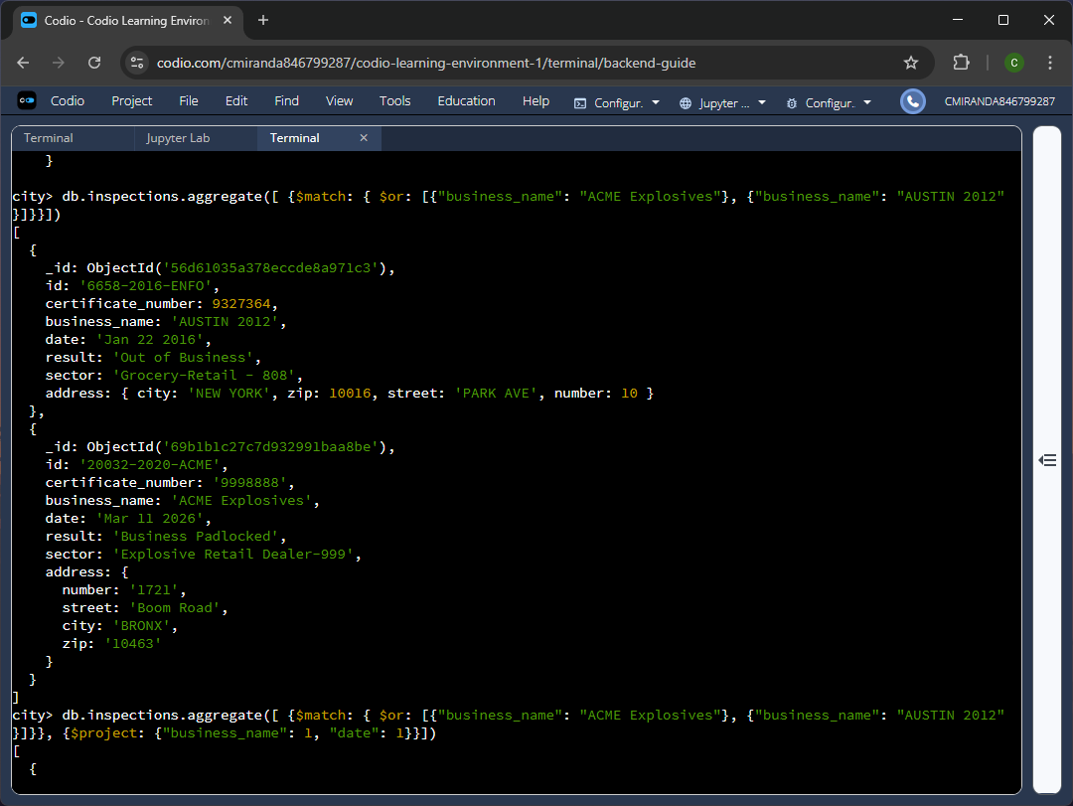
Figure 4B-1 – Using the Aggregate function to filter for documents that match the “business_names” of “ACME Explosives” and “AUSTIN 2012.”
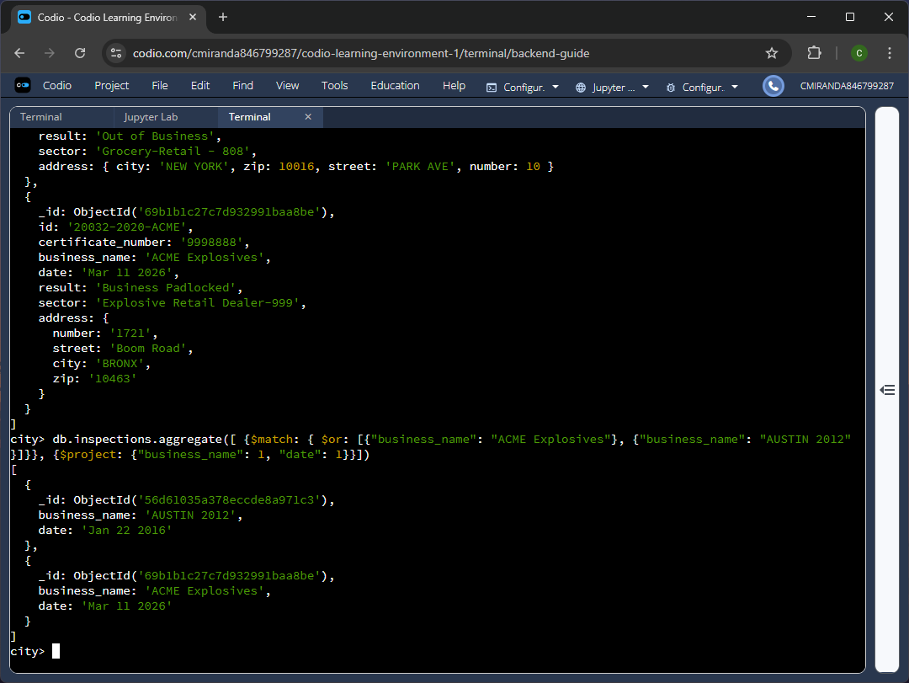
Figure 4B-2 – Using the same aggregate function and defining a projection to displaying only the “business_name” and “date” fields.
Upon filtering and displaying only the necessary fields, the business “AUSTIN 2012” has a date of “Jan 22, 2016” and “ACME Explosives” has a date of “Mar 11, 2026” so based on these values there is a date difference of 3701 days, or specifically, a difference of 10 years, 1 month, and 17 days.
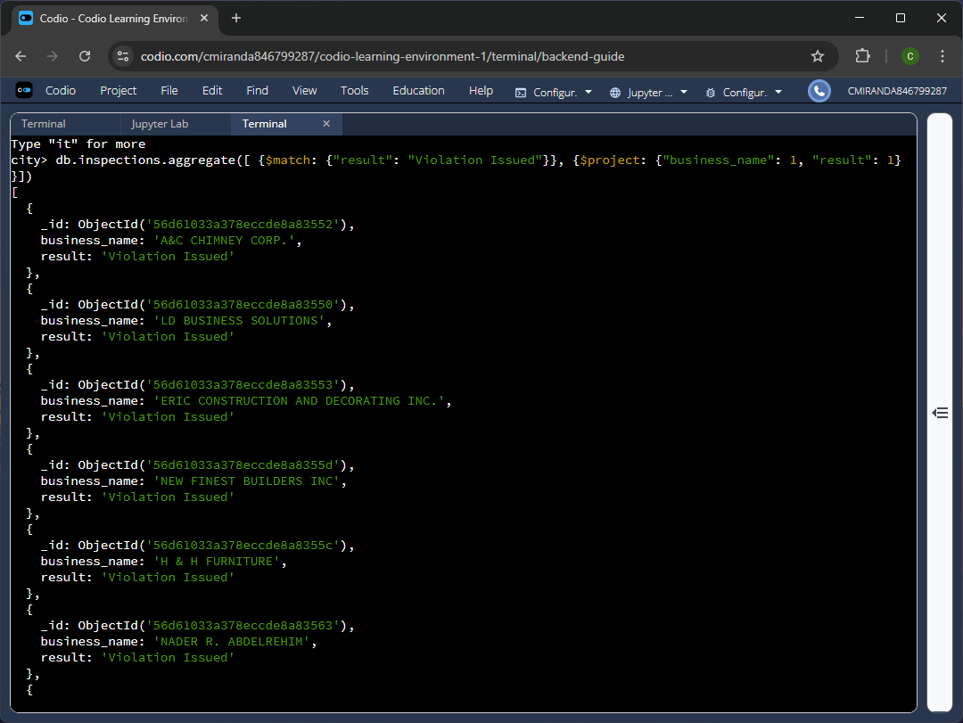
Figure 4C-1 – Using the aggregate function to filter for documents whose “result” field matches “Violation Issued” and using a projection to show only the “business_name” and “result” field
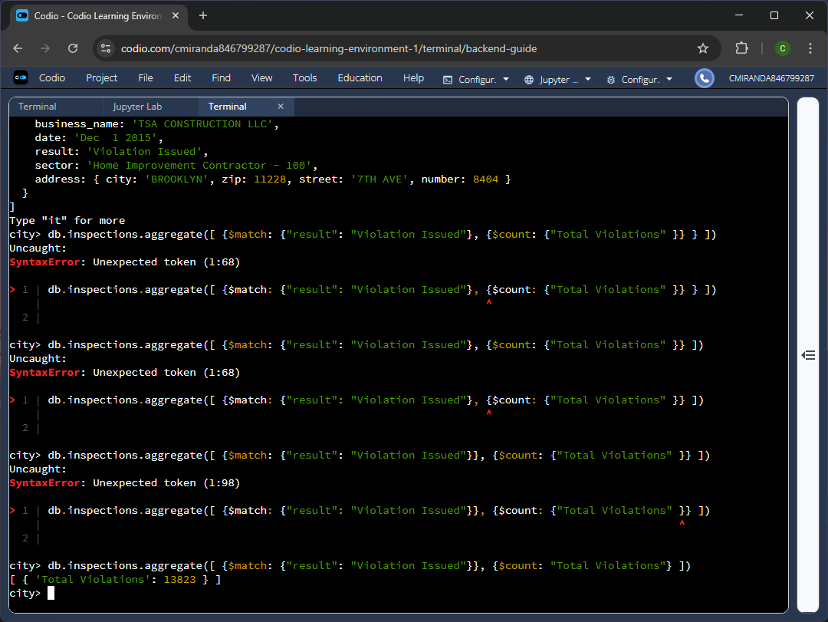
Figure 4C-1 – Using the same aggregation function but removing the projection and instead using the count feature to determine the total number of documents that match the filter.
Upon filtering all documents for those that have a value of “Violation Issued” for their “result” field, its shows that the collection has a total of 13823 documents match said criteria.
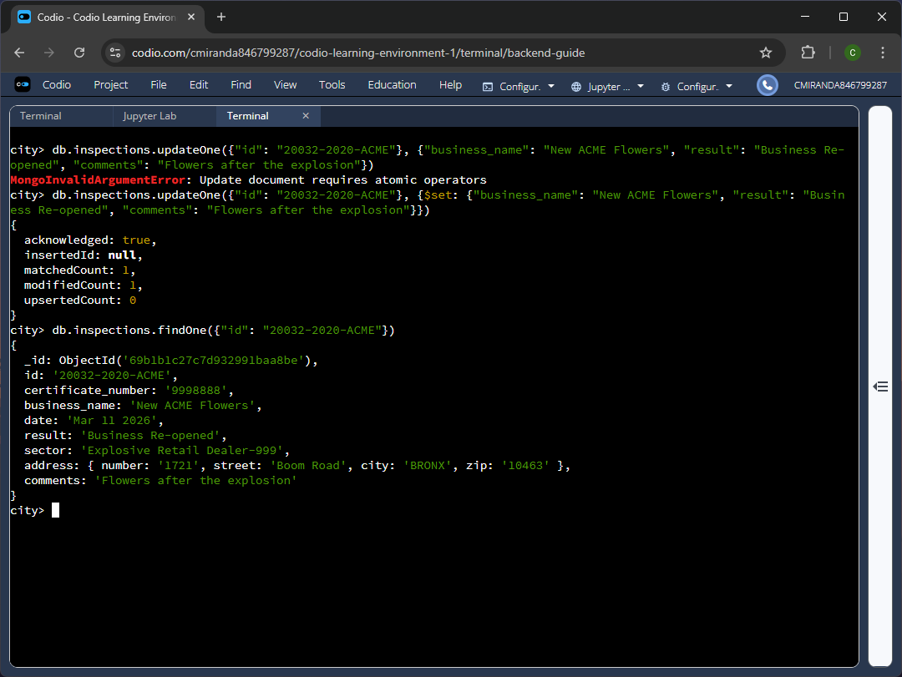
Figure 5 – Updating the first document whose id matches “20032-2020-ACME” and updating various fields values. Afterwards, the findOne function is used to validate the changes.
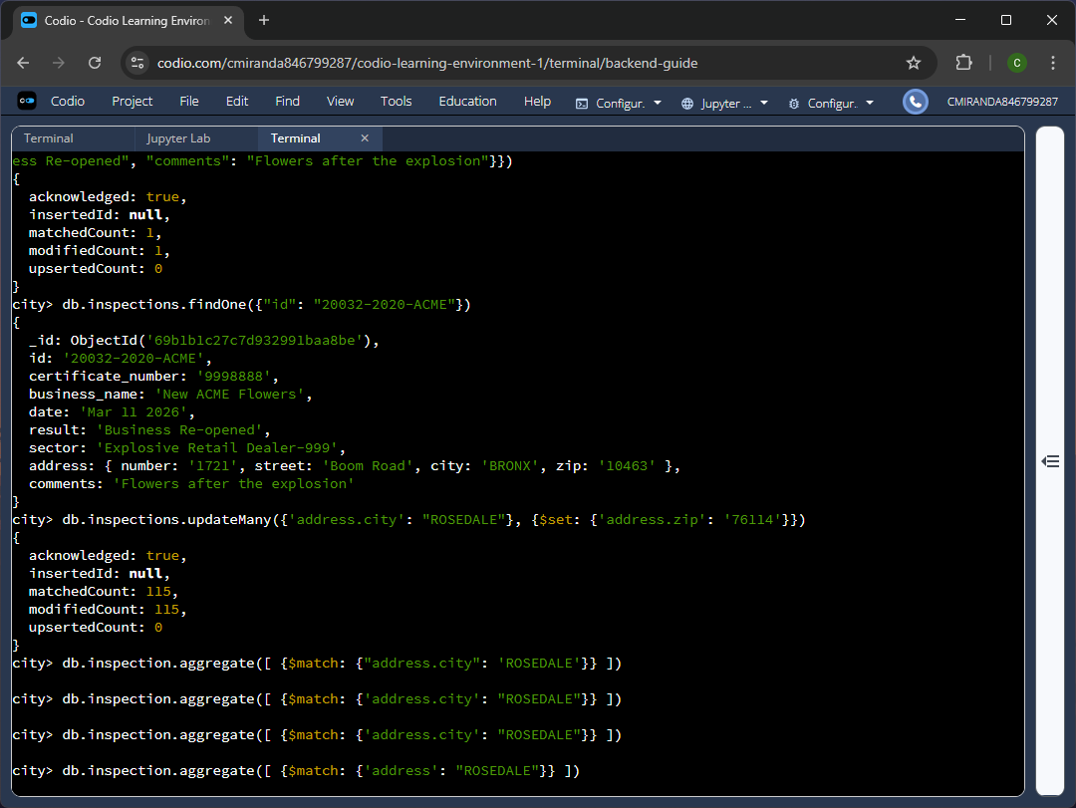
Figure 6A-1 – Using the updateMany function and filtering based on the nested document ‘address’ and specifically its ‘city’ field and then updating the same nested document’s ‘zip’ field value.
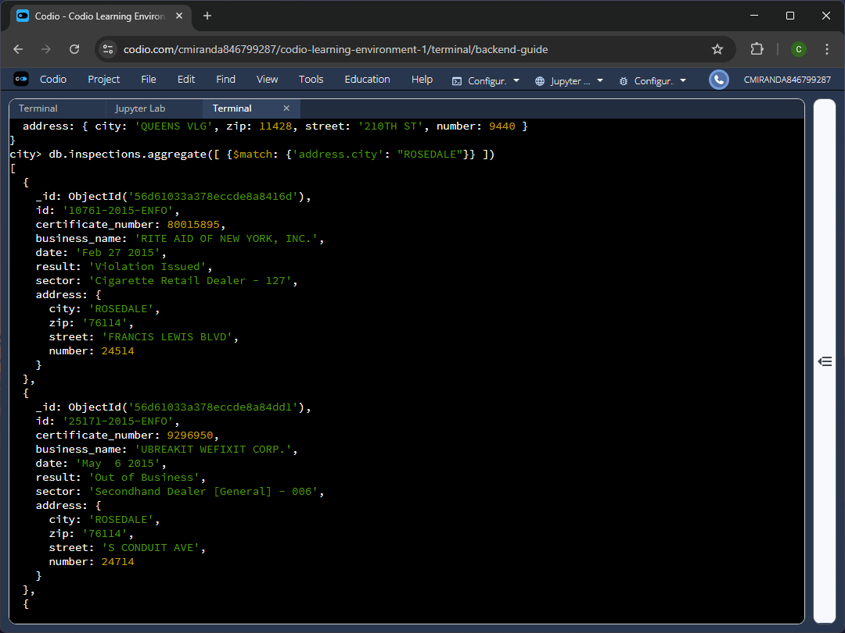
Figure 6A-2 – Using the aggregate function to filter all documents and show only those whose nested document’s ‘city’ field matches the value “ROSEDALE” to validate the updates.
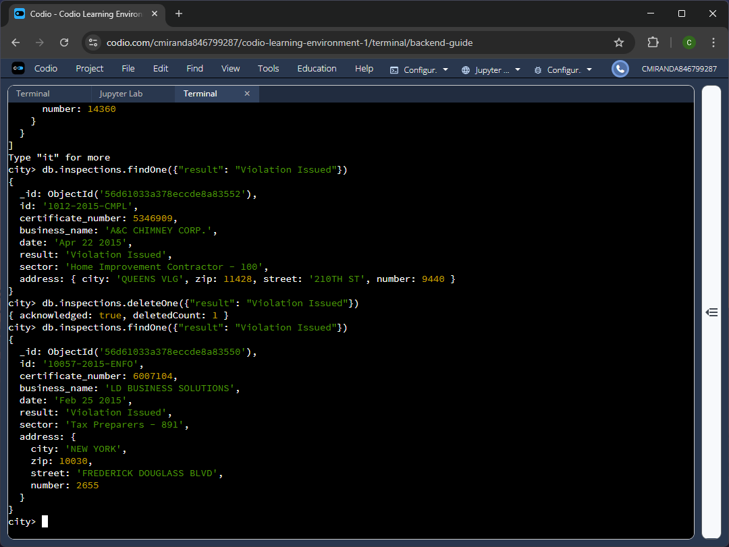
Figure 6B – Removing the first document whose “result” field matches the value “Violation Issued” and then confirming the deletion using the findOne function.

